Politics in 20th Century Ireland
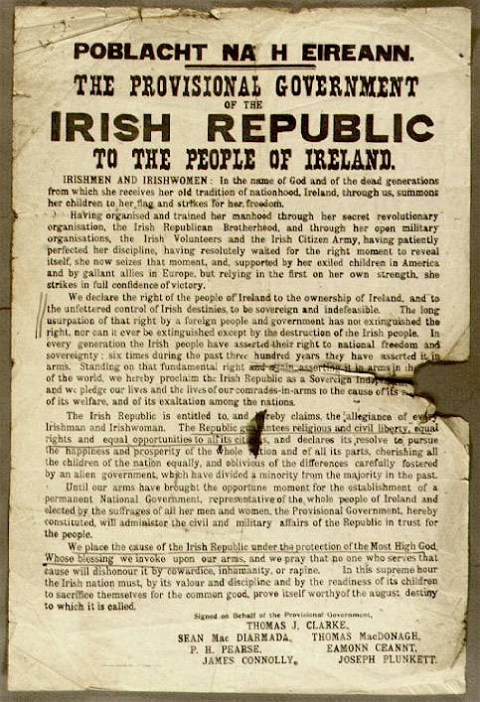
Timeline: 1900 - 1923
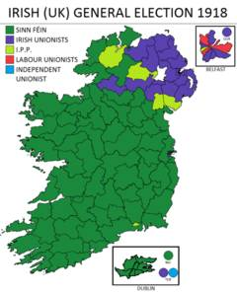
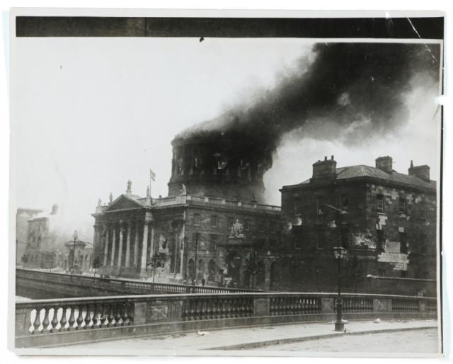
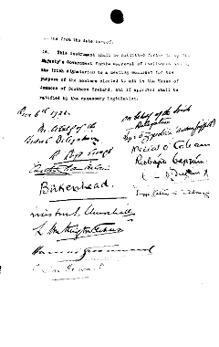
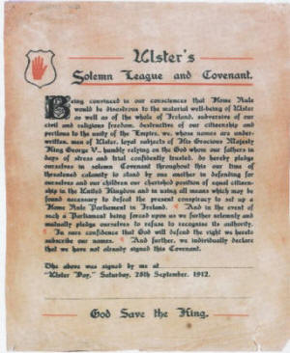

Government of Ireland Act
(1920)
N. Ireland State
formed
Dáil
Declaration of Independence
Irish Civil War
1922 - 1923
3rd Home Rule Bill & Solemn League & Covenant
Ulster Volunteers formed
1905 1911 1912 1913 1914 1916 1918 1919 1920 1921 1922 1923
Anglo-Irish Treaty signed
Irish Free State formed
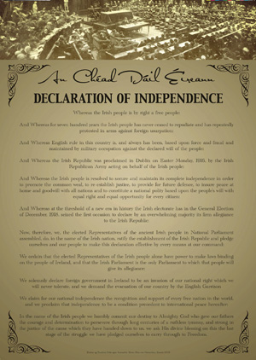
Proclamation of the Irish Republic

