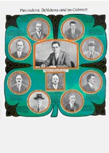
Politics in 20th Century Ireland
Timeline: 1923 - 1949
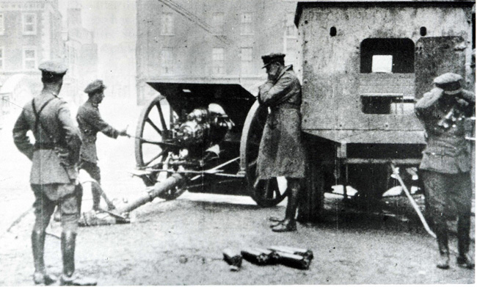
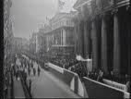
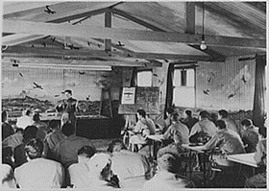
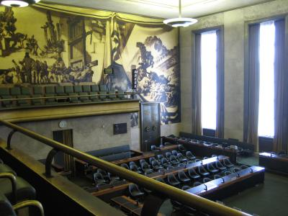
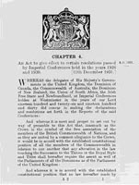
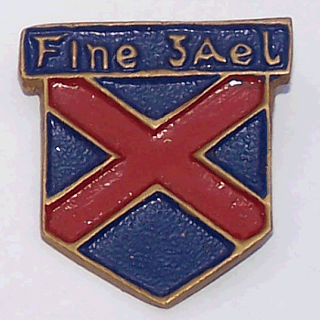
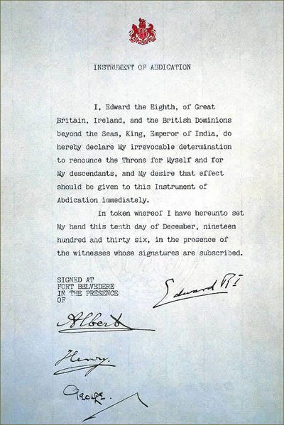
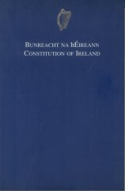
Bunreacht na hEireann
(1937)
Irish Civil War
1922 - 1923
‘Emergency’
1939 - 1945
Emergency Powers’ Act (1939)
Return of
‘Treaty Ports’ (1938)
Republic of Ireland Act
(1949)
1923 1924 1927 1931 1932 1933 1936 1937 1938 1939 1945 1948 1949
External Relations’ Act
(1939)
Fine Gael formed
Statute of Westminster
(1931)
Irish Free State register Anglo-Irish Treaty with League of Nations’ Secretariat
Fianna Fáil win
1932 General Election
