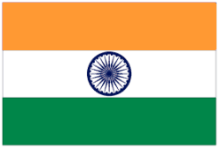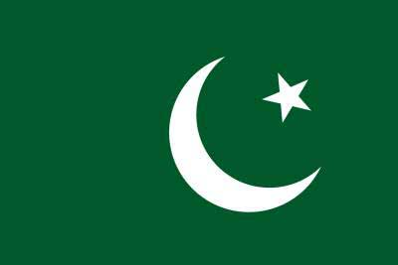
British Withdrawal from India,
1945 – 1947
The Struggle for Indian Independence & Creation of Pakistan
________________________________________________________

"A moment comes, which comes but rarely in history, when we step out from the old to the new, when an age ends, and when the soul of a nation, long suppressed, finds utterance."
Jawaharlal Nehru

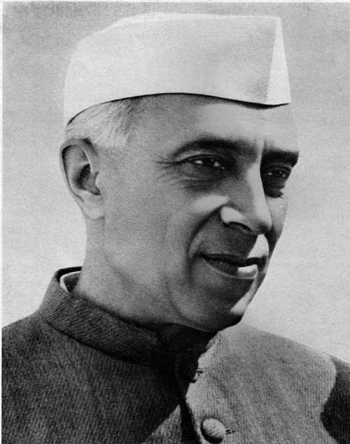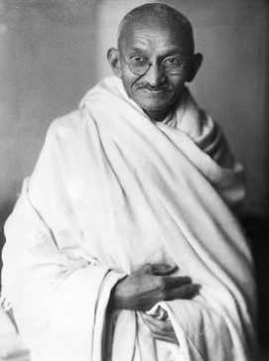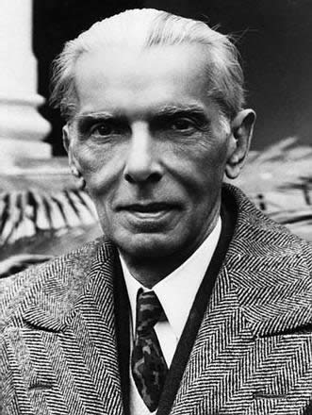
Jawaharlal Nehru
(1889 – 1964)
‘Pandit’ (Teacher)
Prime Minister of India,
1947 - 1964

Mohandas ‘Mahatma’ Gandhi
(1869 – 1948)
‘Bapu’ (Father of the Nation) &
Prominent leader of the Indian National Congress (INC)

Mohammed Ali Jinnah
(1876 – 1948)
‘Quad-e-Azam’ (Great Leader)
Former member of the Indian Congress Party and leading advocate of Muslim separation & statehood (Pakistan)

Section I: Britain & India 1885 - 1920
- British ‘Raj’ & Demographics of Religion in India
- Key Personalities
- The Movement for Indian Independence: 1885 – 1916
- Government of India Act (1919)
  - Simon Commission (1927)
Section II: India 1920 - 1946
- Mohandas Gandhi, Jawaharlal Nehru & the Congress Party: 1920 - 1935
- Government of India Act (1935)
- India during World War II
- Muslim League calls for independent Pakistan: 1940 – 1946
  - Lahore Resolution
- British Labour Government: 1945
  - “morally committed to speed up the process of independence for India”
- Provincial Elections: 1946
Section III: British Withdrawal from India 1945 - 1947
- Lord Louis Mountbatten, Viceroy of India: 1947 – 1948
  - The Mountbatten ‘Partition Plan’ 1947
- Indian Independence Act (1947)
- Sir Cyril Radcliffe & the Boundary Commission: 1947
- British Withdrawal: 17th August 1947
- The dispute over Kashmir 1947 – 1948
- Legacies: India & Pakistan

Key Personalities
Write a short synopsis on the career& roles of each of the following key personalities in relation to the Independence & Partition of India.
Mohandas ‘Mahatma’ Gandhi (Indian Congress Party)
___________________________________________________________________________________________________________________________________________________________________________________________________________________________________________________________________________________________________________________________________________________________________________________________

Jawaharlal Nehru (Indian Congress Party)
_________________________________________________________________________________________________________________________________________________________________________________________________________________________________________________________________________________________________________________________________________________________________________________________________________________

Mohammed Ali Jinnah (Muslim League & former Congress Party)
___________________________________________________________________________________________________________________________________________________________________________________________________________________________________________________________________________________________________________________________________________________________________________________________________________________
Lord Louis Mountbatten (Viceroy of India, 1947 – 1948)
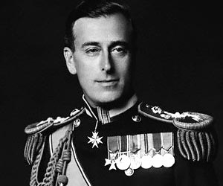
_________________________________________________________________________________________________________________________________________________________________________________________________________________________________________________________________________________________________________________________________________________________________________________________________________________________________________________________
Section I
- The British ‘Raj’ in Asia
- British rule in areas of Bangladesh, Burma, India & Pakistan was known as the British ‘Raj’
- Direct Rule of ¾ of the population by British Viceroy (representing the King of Britain in India.
- Also, a Secretary of State for India was included in the British Government Cabinet.
- The remainder were ruled by local Princes, divided into generally two different categories:
  - Hindu Native States were run by local Hindu ‘Rajas’ or ‘Maharajas’ (majority)
  - Muslim Native States also run by Muslim ‘Nawabs’ (minority)
Religious Demographics of India
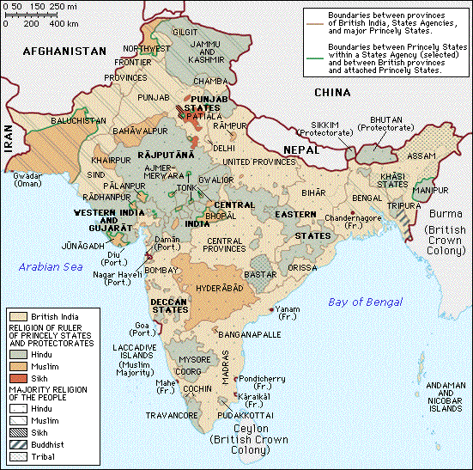
Religions
Hindu: 250 million
Muslim: 90 million

Sikh:
Christian: 25 million
Buddhist:
- British-ruled area was divided into states and ruled by a governor, supported by an Indian Civil Service
- Small British Settler presence (168,000 in 19331). These settlers were most often employed as Governors, civil servants, businessmen, soldiers and their families.
- Conservative Party of Britain strongly supported British Rule in India (Imperialism)
- Labour Party & Liberal Party were more progressive and supported greater local autonomy and equality for Indians.
(B) Emergence of Indian Nationalism
Two organisations were founded around the end of the 19th Century that reflected a growing widespread demand for Indian autonomy, while underlining the role of religion in pre-determining early political divisions:
Muslim League
(1906)
- In response to the Hindu-dominated National Congress, Muslims formed their own group to protect Muslim rights.

Indian National Congress
(1885)
- Initially, a moderate party seeking greater equality for Indians in government jobs, education etc.

Lucknow Pact (1916)
A demand for greater self-government in India & separate electorates for Hindu & Muslim peoples.

(C) Early British Response to Indian Nationalism
In response to Indian organisations demanding greater autonomy and independence the British Government attempted to modernise its relationship with India, while simultaneously attempting to offset demands for independence.
- 1909: wealthy Indians allowed to vote for provincial councils that advised Governors. 1st introduction of separate electorates for Muslims & Hindus N.B.
- 1919: Government of India Act. This gave Indians a limited role in the running of local and regional affairs such as education & health.
- ‘Amritsar Massacre’ (General Dyer orders his troops to open fire on a peaceful protest, killing 379 civilians)
REMEMBER: This was a turbulent period for Britain. Fighting a World War between 1914 & 1918, dealing with constant upheaval in neighbouring Ireland e.g. Home Rule Crisis 1912 – 1914, the 1916 Rising and Sinn Féin’s 1918 Abstentionist policy and the outbreak of the Irish War of Independence, 1919 – 1921. The British Empire was under almost constant attack and criticism. Attempting to hold the colonies together became more difficult politically.

Government of India Act (1919)
- ‘Transferred List’: Created a dual form of government – ‘dyarchy’ – whereby certain areas of government were enlarged and participation by Indians was increased. Agriculture, local government, health and education were some of the areas made more accessible to local Indian participation
- ‘Reserved List’: Areas where the Viceroy continued to exercise control and administration were Defence, Foreign Affairs & Communications.
- Created a High Commissioner for India, who resided in Britain representing Indian interests within the Commonwealth.
- The Imperial Legislative Council was enlarged, creating a lower House and an Upper House. The Upper House contained representatives of the ‘Princely States’.
- This act covered the period 1919 – 1929. It was brought about as a result of India’s participation in World War One & also due to the continuing demand for greater autonomy by Indians.
Reaction:
General disappointment amongst Indians at the limited scope of change brought about by this Act. The Upper House of the Imperial Legislative Council became a tool for British indirect control of India, offsetting the political parties demanding greater independence for India.

Simon Commission (1927)
- Created to examine the effects of the Government of India Act (1919).
- No Indian representatives on the commission, therefore was boycotted by Indian nationalists.
- In response to this, the Indian National Congress called for a complete British withdrawal by 1929. The British Government flatly refused.
Labour Party Government (1929)
- Labour Party formed a government in 1929. Indian Nationalists saw an opportunity to further their demands for independence, as a large anti-colonial group existed within the Labour Party. However, round table talks in London between the Labour Government & Indian politicians failed to come to any agreement.

