Age | Time Period | Settlements | Housing | Food | Tools | Clothes
Palaeolithic  (Old Stone Age) | Up to 10,000 - 7000 BC  ‘Nomads’ | None: nomadic hunter-gatherers | None -  Cave dwellers. | Meat of large animals.  Did not know how to grow crops or farm. Hunted animals in groups | Stone tools, very rudimentary.  Sharpened stones. | Basic garments made from animal skins
Mesolithic  (Middle Stone Age) | 7000 – 4000 BC  ‘Hunter-gatherers’  ‘Nomads’ | Lived near rivers, lakes and/ or coasts  Mount Sandel,  Co. Derry | Made of saplings, interwoven with other branches and covered by skins, grass, bushes or leaves  Hearth (fireplace) in centre of the house | Deer, pigs, salmon.  Hazelnuts, apples  Cooked food on spits | Scrapers, arrowheads & hand axes made from microliths – flintstones and stone axes | Clothes made from animal skins
Neolithic  (New Stone Age) | 4000 – 2300 BC  ‘Farmers’ | First farmers.  Lough Gur, Co. Limerick.  Céide Fields, Co. Mayo.  PERMANENT SETTLEMENTS | Rectangular in shape. Timber poles driven in ground with stones holding them in place.  Wattle & Daub used to seal the walls.  Thatched roof with a hole in centre acting as a chimney. | Grew crops, & domesticated animals e.g. cattle, pigs, sheep.  Grew wheat & barley: for bread & porridge.  Ploughed the land and made stone borders around fields. | Mattocks (for breaking up hard ground)  Wooden ploughs  Polished Stone Axes, bows & arrows, spears. | Animal skins.  Wool was spun to make woolen clothes.
Neolithic Burial Customs

Type | Description | Photo
Court Cairns | Semi-circular court (open space), with an entrance leading to a passage and a burial chamber.  Large upright stones formed the entrance.  Passage & chamber covered with a ‘cairn’; a mound of smaller stones.  Bodies cremated and placed in pots inside the chamber. | 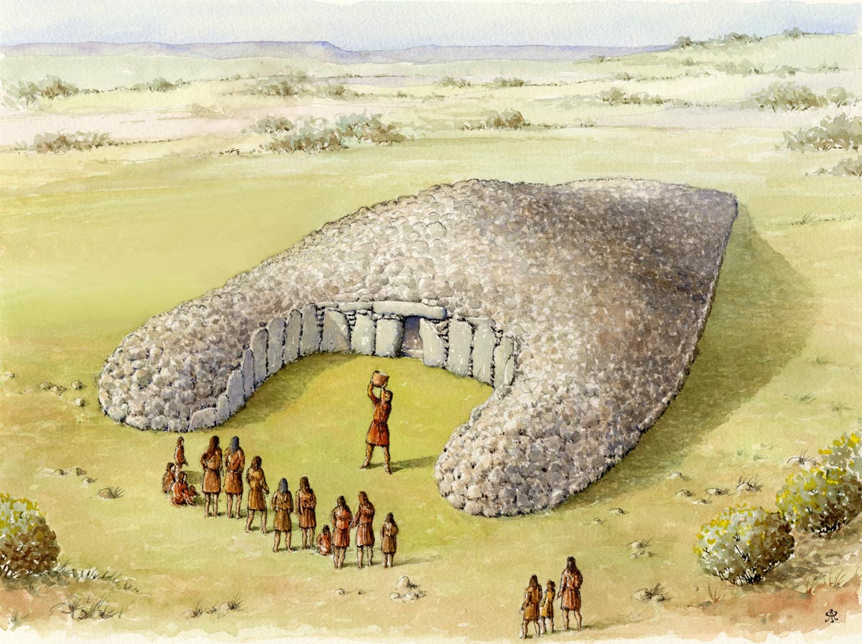
Portal Dolmens | Three large upright stones supported a capstone (Dolmen).  Some capstones over 40 tonnes in weight. Two large upright stones acted as portals (doorways) with third upright stone at the back. Bodies cremated and placed in pots inside the chamber. | 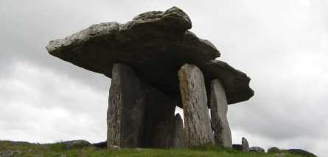
Passage Tombs | A Circular mound that covers a long passage leading to a burial chamber.  Large upright stones form the passageway with large capstones which hold up the roof.  Corbelled roof. Roof-box over the entrance doorway (sunlight on 21st December enters and lights up the entire chamber. | 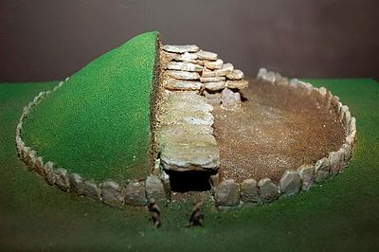

Microlith | Microliths are small stones and pieces of flint used in tools
Megalith

