The Iron Age & the Celts
- Celts came to Ireland roughly 500 BC (2,500 years ago)
- Celts brought iron to Ireland (The Iron Age)
- Celts originated (came from) Central Europe (Halstatt & La Tene) and spread east, west, north and south throughout Europe
- The Celts left no written accounts about themselves
- A warrior society
- Each King ruled a TUATH (kingdom); there were about 150 tuatha in Celtic Ireland.

Celtic Society
Ri
Derbhfine
(royal family)

Nobles
(warriors)
Aos Dana
(Fili / Brehons / Druids / Bards)

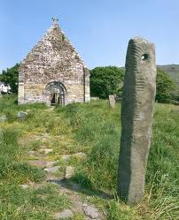
Tanaiste
(successor to king)

Ogham
Ogham writing was the practise of cutting notches into the edge of a standing stone to record the surname of a person buried beneath it.

Celtic Craftsmanship
- Celts were known to wear gold brooches.
- Wealthy Celts also wore torcs (a type of necklace woven in gold) : The Broighter Torc
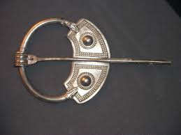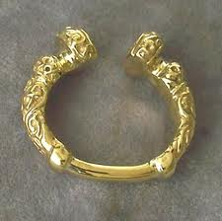
Celtic Brooch
The Broighter Torc

The Aos Dana
- Brehons (judges)
Brehon Law was the ancient Celtic system of law. If someone broke the law, the punishment was usually a fine known as an ‘eric’.
- Druids (pagan priests)
Druids were pagan priests who performed ceremonies such as the Celtic festivals and often used ritual sacrifices of animals to please their gods.
- Fili (poets)
The ‘fili’ were poets/historians who trained for twenty years and learned the history and customs of the Celts. They composed poems which told the history of the Celts and learned them by heart. The ‘Bards’ composed poetry & music which praised and commemorated the king and his royal family.
- Craftsmen
Craftsmen were carpenters and metalworkers.

Celtic Farming
- Celts grew wheat, rye and oats.
- They also reared cattle, and cattle raiding was common. The amount of cattle a Celt had determined their wealth.
- Cooking was done in a Fulacht Fiadh
- Smiths made bronze and iron tools.

Celtic Housing
Crannog:
- An artificial island in the middle of a lake.
- Built up with layers of of stone and wood.
- Linked to mainland via a bridge.
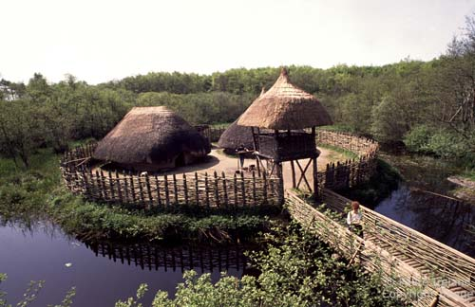

Ringfort:
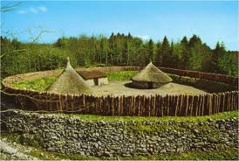
- Circular in shape.
- Built on raised areas.
- Surrounded by ‘rings’ of wooden fencing or earth.

