Humankind goes interstellar
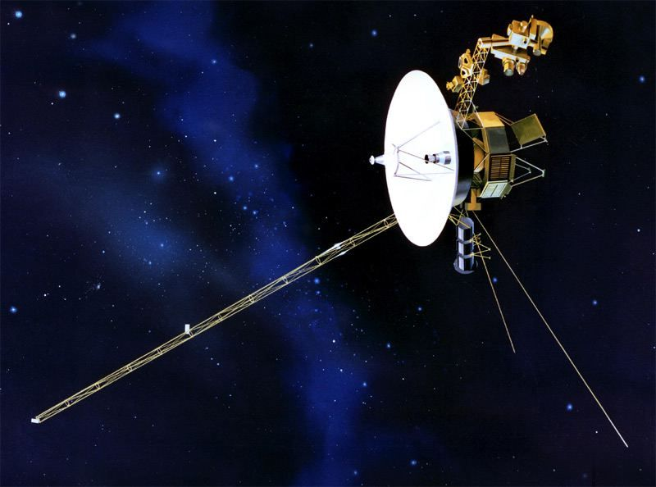

It’s only taken 36 years but, after a couple of false starts, NASA finally declared that their Voyager 1 spacecraft had gone interstellar. Telltale measurements from the probe revealed that it had slipped out from the area where the sun’s electromagnetic influence reigns and tasted the space between stars. Not bad for a piece of vintage '70s hardware with only enough memory onboard to hold an average-size JPEG file.
Next stop: the Oort Cloud, which represents the edge of the sun’s gravitational influence and the end of the solar system. But don't hold your breath. It's going to take about 30,000 years to get there.
Image: NASA

Source: http://www.wired.com/2013/12/top-scientific-discoveries-2013

- It’s only taken – (Irony) It has taken 36 years!
- False starts – unsuccessful attempts to begin
- Telltale – clues that show something to be true
- Reigns – has influence and power over a region
- Not bad for – It is a pretty good performance for
- Vintage – out of date, quite old (but not antique)
- But don’t hold your breath – It will not happen soon

